Road traffic survey
Date Tuesday 16/01/24 PM
Sunset 21:13
 | Looking north | Looking south
20:43 | 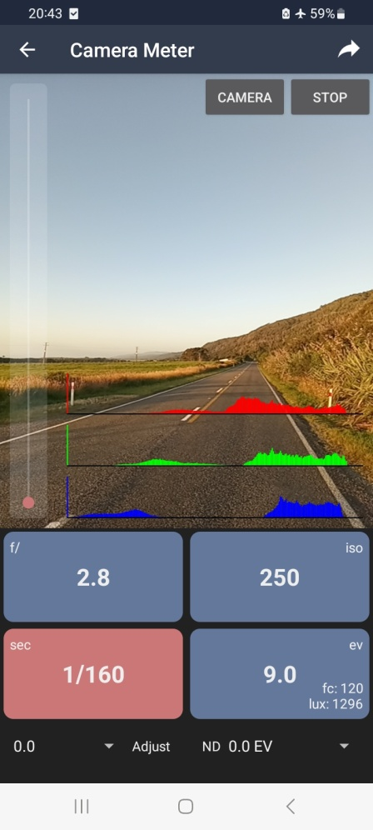 | 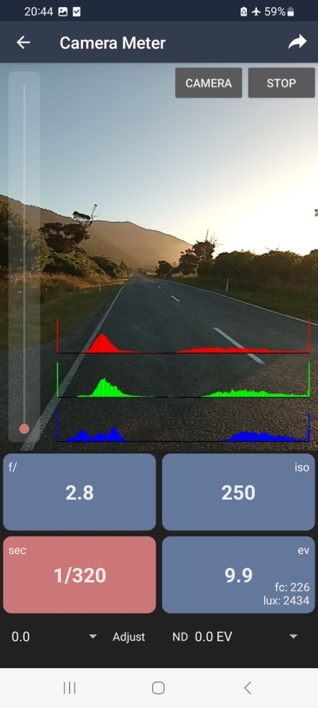
 |  | Looking into the sun on this photo, caused the app to change some settings which meant lux wasnt updating for the following 4 photos. Sensor meter data is good though, in spreadsheet.
21:13  (sunset) | 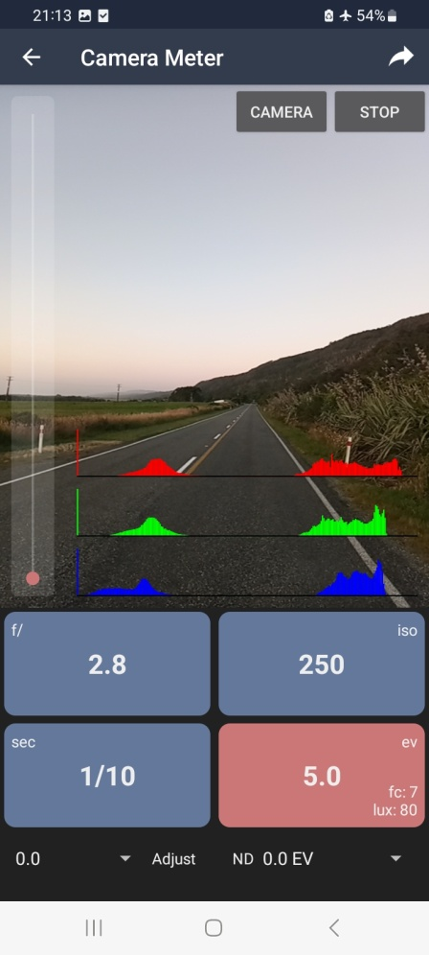 | 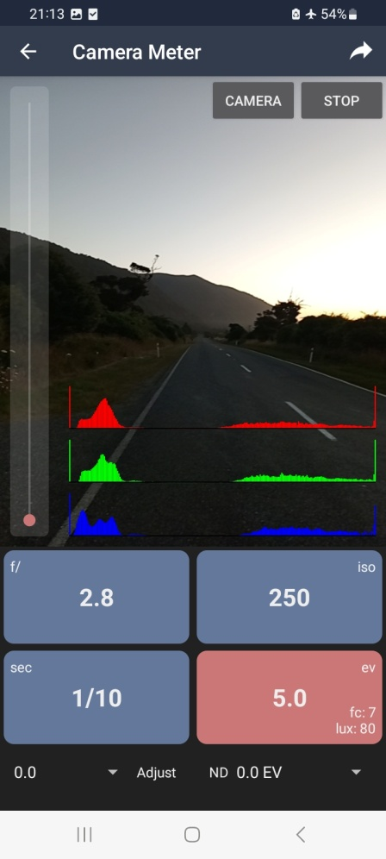
 | Misreading on lux | Misreading on lux
21:43 | 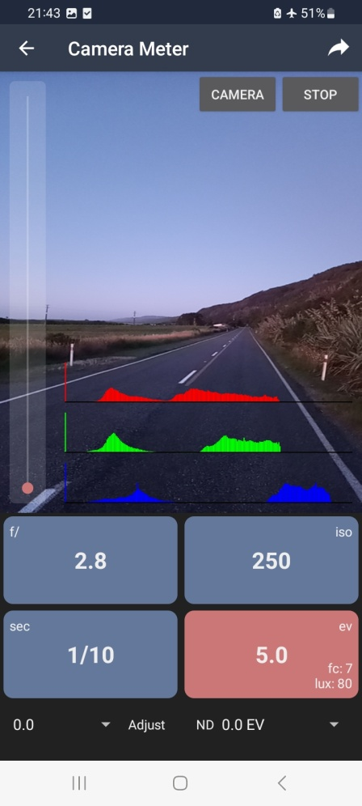 | 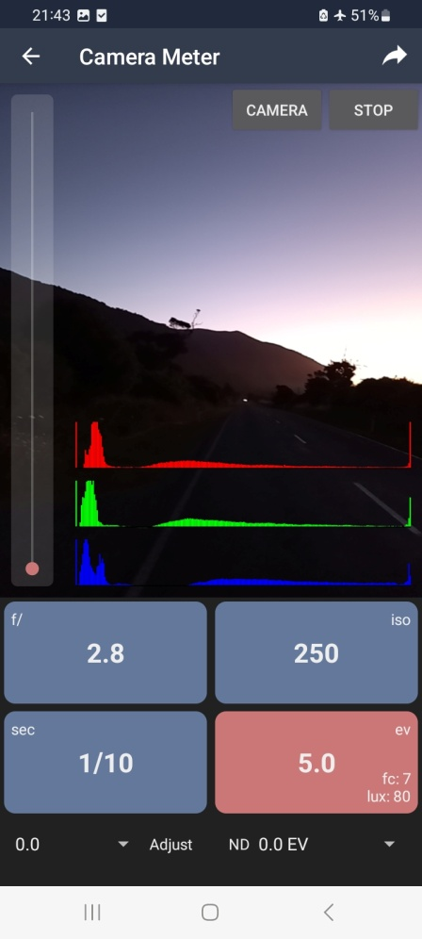
 | Misreading on lux | Misreading on lux

